TS C104 V3.0.1 1999-10
Technical Specification
CWTS

China Wireless Telecommunication Standard (CWTS);
Working Group 1 (WG1);
Spreading and modulation

Intellectual Property Rights 3
Foreword 3
1 Scope 3
2 References 3
3 Definitions, symbols and abbreviations 4
3.1 Definitions 4
3.2 Symbols 4
3.3 Abbreviations 4
4 General 4
5 Data modulation 5
5.1 Symbol rate 5
5.2 Mapping of bits onto signal point constellation 5
5.3 Pulse shape filtering 5
6 Spreading modulation 6
6.1 Basic spreading parameters 6
6.2 Spreading codes 6
6.3 Scramble codes 7
7. Generation of synchronisation codes 7
7.1 SYNC 7
7.2 SYNC1 9
Annex A: Scramble Codes 9
Annex B: SYNC Codes 10
Annex C: SYNC1 Codes 11
History 13

Intellectual Property Rights

Foreword
This Technical Specification (TS) has been produced by CWTS working group 1(CWTS WG1).The contents of this TS are subject to continuing work within CWTS WG1 and may change following formal TSG approval.

1 Scope
This document establishes the characteristics of the spreading and modulation in the TD-SCDMA mode. The main objectives of the document are to be a part of the full description of the Layer 1, and to serve as a basis for the drafting of the actual technical specification (TS).
<Editor’s note: The content has to be reviewed according to the TD-SCDMA rules. >

2 References
The following documents contain provisions which, through reference in this text, constitute provisions of the present document.
References are either specific (identified by date of publication, edition number, version number, etc.) or non-specific.
For a specific reference, subsequent revisions do not apply.
For a non-specific reference, subsequent revisions do apply.
A non-specific reference to an ETS shall also be taken to refer to later versions published as an EN with the same number.
- CWTS TS C101(V2.0.0)
- CWTS TS C102(V2.0.0)
- CWTS TS C105(V1.2.0)

3 Definitions, symbols and abbreviations

3.1 Definitions
For the purposes of the present document, the following definitions apply:
<defined term>: <definition>.

3.2 Symbols
For the purposes of the present document, the following symbols apply:
<symbol> <Explanation>

3.3 Abbreviations
For the purposes of the present document, the following abbreviations apply:
CDMA | Code Division Multiple Access
PN | Pseudo Noise
QPSK | Quadrature Phase Shift Keying
DwPTS | Downlink Pilot Symbol
UpPTS | Uplink Pilot Symbol
DCA | Dynamic Channel Allocation
OVSF | Orthogonal Variable Spreading Factor
SF | Spreading Factor

4 General
In the following, a separation between the data modulation and the spreading modulation has been made. The data modulation is defined in section 5 and the spreading modulation in section 6.

Table 1: Basic modulation parameters.
Chip rate | 1.28Mcps
Carrier spacing | 1.6MHz
Data modulation | QPSK or 8PSK(optional)
Chip modulation | Root-raised cosine  roll-off α = 0.22
Spreading characteristics | Orthogonal  Qchips/symbol,  where Q = 2^{p}, 0 <= p <= 4

5 Data modulation

5.1 Symbol rate
The symbol rate and duration are indicated below:
T_{s} = Q × T_{c}, where T_{c} = 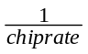= 0.78125 μs, the symbol time T_{s} depends upon the spreading factor Q.

5.2 Mapping of bits onto signal point constellation
A certain number K of CDMA codes can be assigned to either a single user or to different users who are simultaneously transmitting bursts in the same time slot and the same frequency. The maximum possible number of CDMA codes, which is smaller or equal to 16, depends on the individual spreading factors, the actual interference situation and the service requirements..
The data modulation is QPSK, thus the data symbols 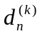 are generated from two interleaved and encoded data bits
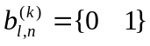 =1,2; =1,2…..K ; n is symbol index (1)
using the equation
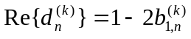 (2)
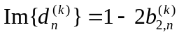 =1,2,……K; n is symbol index
Equation (2) corresponds to a QPSK modulation of the interleaved and encoded data bits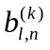 of equation (1).

5.3 Pulse shape filtering
The pulse shape filtering is applied to each chip at the transmitter. The impulse response of the pulse shape filter h(t) shall be a root-raised cosine. The corresponding raised cosine impulse h(t) is defined as
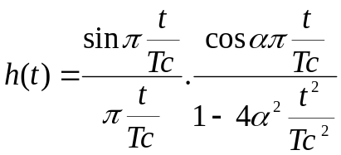 (3)
The roll-off factor is α = 0.22.
T_{c} is the chip duration: T_{c} = = 0.78125μs

6 Spreading modulation

6.1 Basic spreading parameters
Each data symbol of equation (2) is spread with a spreading code 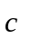 of length Q={1 , 2, 4, 8 ,16 }

Spreading codes
The spreading factor Q may varies from 1~16. The data symbol is spread with Orthogonal Variable Spreading Factor (OVSF) codes, which is showed follow
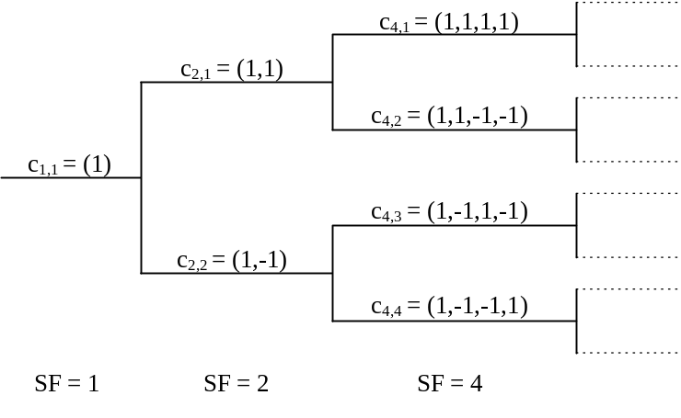
Figure 1. Code-tree for generation of Orthogonal Variable Spreading Factor (OVSF) codes.
In Figure 1, the OVSF code is described as C_{SF,code number}, where SF_{d,n} represents the spreading factor of n^{th} code channel. Each level in the code tree defines channelization codes of length SF, corresponding to a spreading factor of SF in 1. All codes within the same code tree cannot be used simultaneously in the same time slot in the same cell.
The generation method for the channelization code can also be explained in Figure 2.

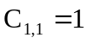

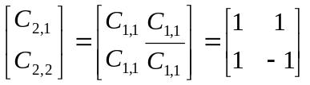
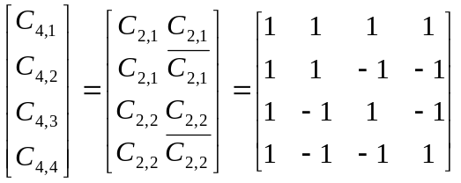
: :
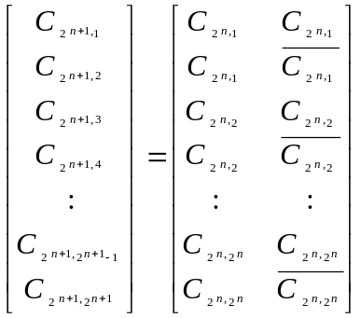
Figure 2. Spreading Code Generation Method

Scramble codes
Scramble codes is used to identify different cells. A set of 22 codes is used as the scramble codes. Scramble code is cell specific, its index is the same with the SYNC code index.(that is , the scramble codes and SYNC codes are in one-one relationship.)
(editor notes: complex scramble code may be used)

7. Generation of synchronisation codes

7.1 SYNC
SYNC is the downlink synchronization code in DwPTS.
GP
(32chips)
SYNC
(64chips)

Figure 3. Burst structure of DwPTS
The code sequences are constructed with the help of two binary m-sequences of length 64, x, and y, respectively. The x sequence is constructed using the polynomial 1+x+x^6.The y sequence is constructed using the polynomial 1+x+x^3+x^4+x^6.
The set of orthogonal Gold Codes are defined as following:
Let n₅ … n₀ be the binary representation of the scrambling code number n (decimal) with n₀ being the least significant bit. The x sequence depends on the chosen code number n and is denoted x_{n} in the sequel. Furthermore, let x_{n}(i) and y(i) denote the ith symbol of the sequence x_{n} and y, respectively
The m-sequences x_{n} and y are constructed as:
Initial conditions:
x_{n}(0)=n₀ , x_{n}(1)= n₁ ,x_{n}(2)= n₂ , …… x_{n}(5)= n₅
y(0)=y(1)= y(2)= ……=y(5)=1
Recursive definition of subsequent symbols:
x_{n}(i+6) =x_{n}(i+1) +x_{n}(i) modulo 2, i=0,…, 56
y(i+6) = y(i+4)+ x_{n}(i+3)+ x_{n}(i+1)+y(i) modulo 2, i=0,…, 56.
Definition of the n:th cell identification code word follows:
C_{,cell,n} = < 0, x_{n}(0)+y(0), x_{n}(1)+y(1), …,x_{n}(62)+y(62) >,
All sums of symbols are taken modulo 2.
Before modulation and transmission these binary code words are converted to real valued sequences by the transformation ‘0’ -> ‘+1’, ‘1’ -> ‘-1’.
The configuration of the code generator is presented in Figure.4
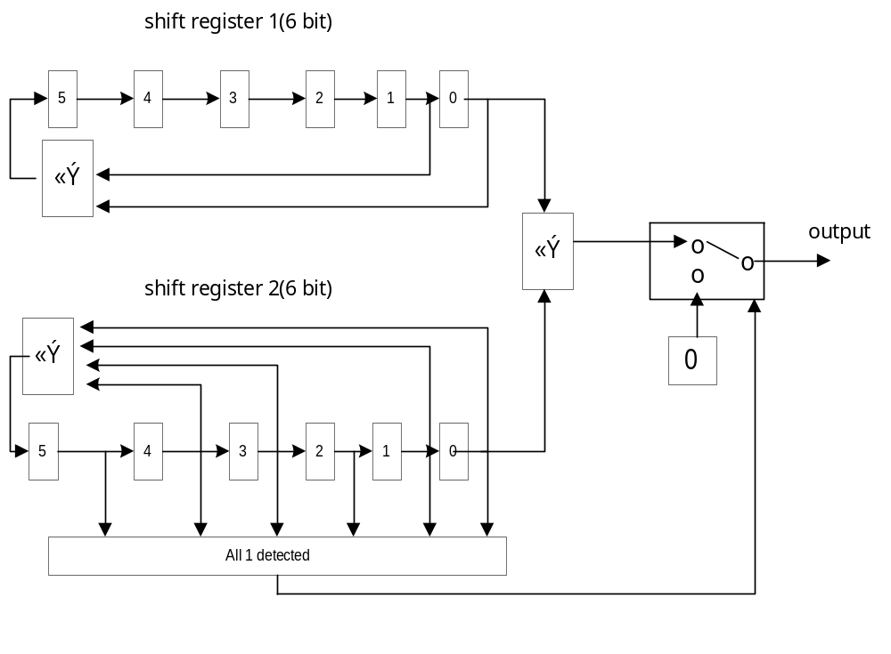Figure 4. 64 chips orthogonal Gold code generator
- The initial value of shift register 1 shall be cell identification code number n (range 0~63)
- The initial value of shift register 2 shall be all ones.
- When all ones of register 2 is detected, shift shall be suspended and "0"shall be inserted.
In the system, 22 codes with relatively good performance are chosen from the above code set, which are listed in Annex B.

7.2 SYNC1
SYNC1 is used to achieve uplink synchronization in UpPTS.

SYNC1
(128chips)
GP
(32chips)
The SYNC1 codes are constructed with the help of binary m-sequences of length 128. The colds are using the polynomial 1+x+x^7 and 1+x^2+x^5+x^6+x^7.
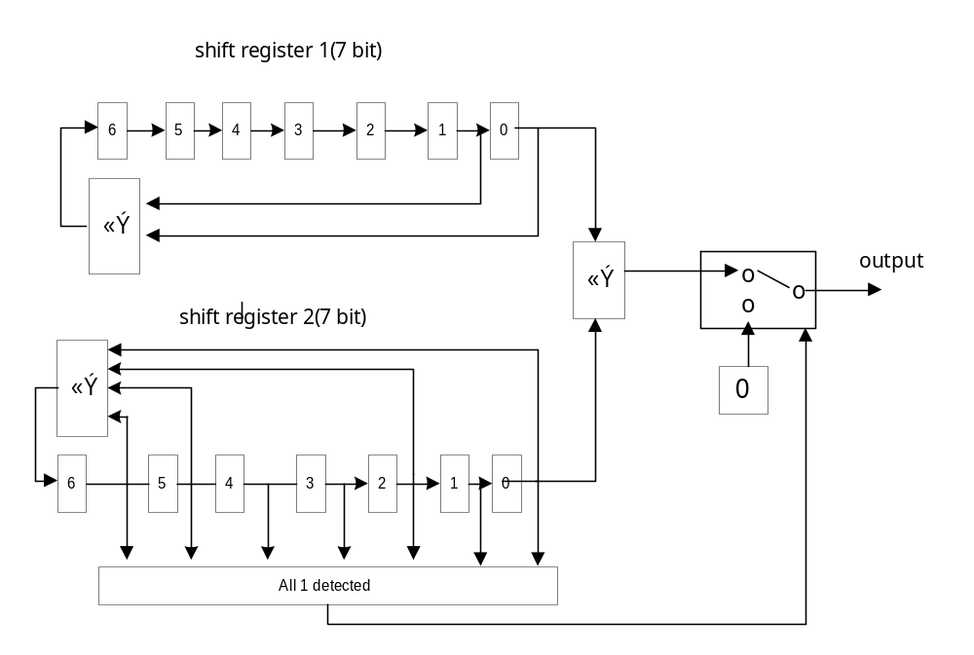 Figure 5. 128 chips orthogonal Gold code generator

- The initial value of shift register 1 shall be range from 0~127
- The initial value of shift register 2 shall be all ones.
- When all ones of register 2 is detected, shift shall be suspended and "0"shall be inserted.

Annex A: Scramble Codes
Scramble code list
code0: | BB4B
code1: | 0563
code2: | 4487
code3: | BB87
code4: | 5F39
code5: | 50C9
code6: | 87BB
code7: | 7B47
code8: | 395F
code9: | 8BB7
code10: | F593
code11: | 78BB
code12: | D1ED
code13: | 7787
code14: | B87B
code15: | FC65
code16: | 74B7
code17: | 774B
code18: | 22E1
code19: | B477
code20: | 8777
code21: | 7877

Annex B: SYNC Codes
SYNC code list
code0 | 7E08629E8E4B766A
code1 | 5FC91CCAE9F1A508
code2 | 3F7636F934981429
code3 | 4627A81279111A22
code4 | 5A304D5402BC2C06
code5 | 33816C957CE84BBC
code6 | 6EE8DDB4BD961FDB
code7 | 621F87D8F5E6404E
code8 | 2D6A211C72E3B91F
code9 | 0CAB5F4815596A7D
code10 | 348495C4E2030635
code11 | 482C5AB144C78130
code12 | 60E32F17804084C9
code13 | 2F9689D307457D98
code14 | 0E57F78760FFAEFA
code15 | 17B9435FF01F11D0
code16 | 67E6D6461EABC940
code17 | 3A8F6767DFD59D27
code18 | 4AD0F27E316145B7
code19 | 7CF4CA51FBEDB2ED
code20 | 24642AEED1DE6F84
code21 | 10BCBA0E6EF45C59

Annex C: SYNC1 Codes
SYNC1 code list
code0 | 7F6A06F82C21D189CA697AEE3CC9156C
code1 | 3FE90CC4A71B4ECA435FCD5F9915DFD3
code2 | 5FA889DAE286016B87C496874BFBBA8C
code3 | 1F2B83E669BC9E280EF22136EE277033
code4 | 6F0B41694B7239F8ECBF8CDA8750429C
code5 | 2F884B55C048A6BB65893B6B228C8823
code6 | 4FC9CE4B85D5E91AA11260B3F062ED7C
code7 | 0F4AC4770EEF76592824D70255BE27C3
Code8 | 775AA5309F8825B1590201F46105BE94
code9 | 37D9AF0C14B2BAF2D034B645C4D9742B
code10 | 57982A12512FF55314AFED9D16371174
code11 | 171B202EDA156A109D995A2CB3EBDBCB
code12 | 673BE2A1F8DBCDC07FD4F7C0DA9CE964
code13 | 27B8E89D73E15283F6E240717F4023DB
code14 | 47F96D83367C1D2232791BA9ADAE4684
code15 | 077A67BFBD468261BB4FAC1808728C3B
code16 | 7B72571C75F52B9583DCC763122F4090
code17 | 3BF15D20FECFB4D60AEA70D2B7F38A2F
code18 | 5BB0D83EBB52FB77CE712B0A651DEF70
code19 | 1B33D2023068643447479CBBC0C125CF
code20 | 6B13108D12A6C3E4A50A3157A9B61760
code21 | 2B901AB1999C5CA72C3C86E60C6ADDDF
code22 | 4BD19FAFDC011306E8A7DD3EDE84B880
code23 | 0B529593573B8C4561916A8F7B58723F
code24 | 7342F4D4C65CDFAD10B7BC794FE3EB68
code25 | 33C1FEE84D6640EE99810BC8EA3F21D7
code26 | 53807BF608FB0F4F5D1A501038D14488
code27 | 130371CA83C1900CD42CE7A19D0D8E37
code28 | 6323B345A10F37DC36614A4DF47ABC98
code29 | 23A0B9792A35A89FBF57FDFC51A67627
code30 | 43E13C676FA8E73E7BCCA62483481378
Code31 | 0362365BE492787DF2FA11952694D9C7
code32 | 7D662E0A00CBAC87EEB3A428ABBA3F92
code33 | 3DE524368BF133C4678513990E66F52D
code34 | 5DA4A128CE6C7C65A31E4841DC889072
code35 | 1D27AB144556E3262A28FFF079545ACD
code36 | 6D07699B679844F6C865521C10236862
code37 | 2D8463A7ECA2DBB54153E5ADB5FFA2DD
code38 | 4DC5E6B9A93F941485C8BE756711C782
code39 | 0D46EC8522050B570CFE09C4C2CD0D3D
code40 | 75568DC2B36258BF7DD8DF32F676946A
code41 | 35D587FE3858C7FCF4EE688353AA5ED5
code42 | 559402E07DC5885D3075335B81443B8A
code43 | 151708DCF6FF171EB94384EA2498F135
code44 | 6537CA53D431B0CE5B0E29064DEFC39A
code45 | 25B4C06F5F0B2F8DD2389EB7E8330925
code46 | 45F545711A96602C16A3C56F3ADD6C7A
code47 | 05764F4D91ACFF6F9F9572DE9F01A6C5
code48 | 797E7FEE591F569BA70619A5855C6A6E
code49 | 39FD75D2D225C9D82E30AE142080A0D1
code50 | 59BCF0CC97B88679EAABF5CCF26EC58E
code51 | 193FFAF01C82193A639D427D57B20F31
code52 | 691F387F3E4CBEEA81D0EF913EC53D9E
code53 | 299C3243B57621A908E658209B19F721
code54 | 49DDB75DF0EB6E08CC7D03F849F7927E
code55 | 095EBD617BD1F14B454BB449EC2B58C1
code56 | 714EDC26EAB6A2A3346D62BFD890C196
code57 | 31CDD61A618C3DE0BD5BD50E7D4C0B29
code58 | 518C53042411724179C08ED6AFA26E76
code59 | 110F5938AF2BED02F0F639670A7EA4C9
code60 | 612F9BB78DE54AD212BB948B63099666
code61 | 21AC918B06DFD5919B8D233AC6D55CD9
code62 | 41ED149543429A305F1678E2143B3986
code63 | 016E1EA9C8780573D620CF53B1E7F339
code64 | 7E6C12813A54EF0ED804158D77708013
code65 | 3EEF18BDB16E704D5132A23CD2AC4AAC
code66 | 5EAE9DA3F4F33FEC95A9F9E400422FF3
code67 | 1E2D979F7FC9A0AF1C9F4E55A59EE54C
code68 | 6E0D55105D07077FFED2E3B9CCE9D7E3
code69 | 2E8E5F2CD63D983C77E4540869351D5C
code70 | 4ECFDA3293A0D79DB37F0FD0BBDB7803
code71 | 0E4CD00E189A48DE3A49B8611E07B2BC
code72 | 765CB14989FD1B364B6F6E972ABC2BEB
code73 | 36DFBB7502C78475C259D9268F60E154
code74 | 569E3E6B475ACBD406C282FE5D8E840B
code75 | 161D3457CC6054978FF4354FF8524EB4
code76 | 663DF6D8EEAEF3476DB998A391257C1B
code77 | 26BEFCE465946C04E48F2F1234F9B6A4
code78 | 46FF79FA200923A5201474CAE617D3FB
code79 | 067C73C6AB33BCE6A922C37B43CB1944
code80 | 7A7443656380151291B1A8005996D5EF
code81 | 3AF74959E8BA8A5118871FB1FC4A1F50
code82 | 5AB6CC47AD27C5F0DC1C44692EA47A0F
code83 | 1A35C67B261D5AB3552AF3D88B78B0B0
code84 | 6A1504F404D3FD63B7675E34E20F821F
code85 | 2A960EC88FE962203E51E98547D348A0
code86 | 4AD78BD6CA742D81FACAB25D953D2DFF
code87 | 0A5481EA414EB2C273FC05EC30E1E740
code88 | 7244E0ADD029E12A02DAD31A045A7E17
code89 | 32C7EA915B137E698BEC64ABA186B4A8
code90 | 52866F8F1E8E31C84F773F737368D1F7
code91 | 120565B395B4AE8BC64188C2D6B41B48
code92 | 6225A73CB77A095B240C252EBFC329E7
code93 | 22A6AD003C409618AD3A929F1A1FE358
code94 | 42E7281E79DDD9B969A1C947C8F18607
code95 | 02642222F2E746FAE0977EF66D2D4CB8
code96 | 7C603A7316BE9200FCDECB4BE003AAED
code97 | 3CE3304F9D840D4375E87CFA45DF6052
code98 | 5CA2B551D81942E2B17327229731050D
code99 | 1C21BF6D5323DDA13845909332EDCFB2
code100 | 6C017DE271ED7A71DA083D7F5B9AFD1D
code101 | 2C8277DEFAD7E532533E8ACEFE4637A2
code102 | 4CC3F2C0BF4AAA9397A5D1162CA852FD
code103 | 0C40F8FC347035D01E9366A789749842
code104 | 745099BBA51766386FB5B051BDCF0115
code105 | 34D393872E2DF97BE68307E01813CBAA
code106 | 549216996BB0B6DA22185C38CAFDAEF5
code107 | 14111CA5E08A2999AB2EEB896F21644A
code108 | 6431DE2AC2448E4949634665065656E5
code109 | 24B2D416497E110AC055F1D4A38A9C5A
code110 | 44F351080CE35EAB04CEAA0C7164F905
code111 | 04705B3487D9C1E88DF81DBDD4B833BA
code112 | 78786B974F6A681CB56B76C6CEE5FF11
code113 | 38FB61ABC450F75F3C5DC1776B3935AE
code114 | 58BAE4B581CDB8FEF8C69AAFB9D750F1
code115 | 1839EE890AF727BD71F02D1E1C0B9A4E
code116 | 68192C062839806D93BD80F2757CA8E1
code117 | 289A263AA3031F2E1A8B3743D0A0625E
code118 | 48DBA324E69E508FDE106C9B024E0701
code119 | 0858A9186DA4CFCC5726DB2AA792CDBE
code120 | 7048C85FFCC39C2426000DDC932954E9
code121 | 30CBC26377F90367AF36BA6D36F59E56
code122 | 508A477D32644CC66BADE1B5E41BFB09
code123 | 10094D41B95ED385E29B560441C731B6
code124 | 60298FCE9B90745500D6FBE828B00319
code125 | 20AA85F210AAEB1689E04C598D6CC9A6
code126 | 40EB00EC5537A4B74D7B17815F82ACF9
code127 | 00680AD0DE0D3BF4C44DA030FA5E6646

History
Document history
Date | Version | Comment
July 1999 | 0.0.1 | Document created. Based on TSGR and TAGR1 TS1.23 v2.0.0
August 6, 1999 | 1.0.0 | Document created. Based on TSGR and TAGR1 TS1.23 v2.0.0  And CWTS TS C1.04 V0.0.1
August 22, 1999 | 1.1.0 | Document created. Based on TSGR and TAGR1 TS1.23 v2.0.0  And CWTS TS C1.04 V0.0.1 and V1.0.0
August 30, 1999 | 2.0.0 | Document updated based on CWTS WG1 Ad Hoc1 #3, Beijing
October 2, 1999 | 2.1.0 | Chip rate change to 1.28Mcps
October11,1999 | 2.2.0
October14,1999 | 3.0.0 | Document accepted by CWTS WG1 Ad Hoc1 #4 CWTS WG1 #5 meeting in Beijing
October15,1999 | 3.0.1 | Complex scramble code change to real scramble code
Editor:Wang Yuezhen
BUPT
Tel.: +86-10-6228-2107
e-mail: cmzhang@bupt.edu.cn

This document is written in Microsoft Word Version 97 and saved in Times New Roma Text Format.

